REGISTRATION FORM
Križevci, 08.-10.11.2019.

22nd Crafts and Business Fair of Koprivnica-Križevci County
EXHIBITOR REGISTRATION |  |  | WE ARE ORDERING additional booth equipment:
Name/company:  Address:  Registry number (VAT no.):  Business Activity (code/description):  We are presenting the following types of goods/services at the fair:  Contact person:  Bank Account No.:  Tel /Fax:  WWW: E-mail: |  |  | Name Catalog No. Dimension Units  SPECIFY INFORMATION FROM THE CATALOGUE (Name, catalog no., dimensions-by necessity, units)
 |  |  | WE ARE ORDERING marketing services:
1. ADVERTISEMENT IN THE FAIR CATALOGUE |  | Price in HRK | I am ordering
1/1 page | black and white | 200,00
½ page | black and white | 110,00
¼ page | black and white | 80,00
1/1 page | color | 450,00
½ page | color | 230,00
¼ page e | color | 170,00
Along with your choice, it is necessary to provide your logo
2. ADVERTISING AREA ON WALL SURFACE | Unit | Price in HRK | I am ordering
Note: empty space reserved for advertisement | m2 | 100,00
3. SPECIAL ADVERTISING AREA | Unit | Price in HRK | I am ordering
Logo on the Fair poster (max. 6 logos) | units | 1.000,00
Flyers for visitors with the layout plan of the fair (5000 units) | 1/16 A4 | 350,00
Second or penultimate page of the fair catalogue | units | 700,00
Last page of the fair catalogue | units | 1.800,00
Logo on the front side of the fair ticket |  | 2.000,00
Logo on the back-side of the fair ticket |  | 1.000,00
4. OTHER SERVICES |  | Price in HRK | I am ordering
Sponsor (package of marketing services) |  | 20.000,00
5. SAJAMSKI MEDIJI | Unit | Price in HRK | I am ordering
Advertisement messages through the fair public speakers – 30 seconds. | 1 advertisement | 15,00
Advertisement messages through the fair public speakers – 60 seconds. | 1 advertisement | 35,00
Advertisement messages through the fair public speakers – 30 seconds. | for 10 and more | 130,00
Advertisement messages through the fair public speakers – 60 seconds. | for 10 and more | 330,00
Advertisement messages through the fair TV 30 seconds | 1 advertisement | 120,00
Advertisement messages through the fair TV 60 seconds | 1 advertisement | 200,00
Advertisement messages through the fair TV 30 seconds | for 10 and more | 1.000,00
Advertisement messages through the fair TV 60 seconds | for 10 and more | 3.000,00
Along with your choice, it is necessary to provide the advertisement text through e-mail, or on a disc, CD-rom, etc. In case of an advertising spot for the fair TV, please provide the advertising material in a DVD format.

PRICES DO NOT INCLUDE VAT !
WE ARE ORDERING exhibit space:

- CLOSED – standard  (walls, counter 1,0x0,8m, table, 4 chairs, high shelf 1,0x0,8x2,5 m, label-bold letters, ) at a cost of 245,00 HRK /m²  * state/sum up the area of purchased modules in m²  ** state the number/code of the wanted module (from the enclosed layout plan) Numbers of modules | m2*
 | **
- CLOSED – half equipped  (walls, label-bold letters, electric wall outlet )  at a cost of 170,00 HRK/m²  * state/sum up the area of purchased modules in m²  ** state the number/code of the wanted module (from the enclosed layout plan) Numbers of modules | m2*
 | **
- OPEN – unequipped  at a cost of 60,00 HRK/m²  * state/sum up the area of purchased modules in m²  ** state the number/code of the wanted module (from the enclosed layout plan) Numbers of modules | m2*
 | **
- COMPULSORY REGISTRATION IN THE FAIR CATALOGUE at a cost of 100,00 HRK
(basic information of exhibitor – name, address, tel – business activity)
For the selected place we approve the following discount:
INSIDE AREA OUTSIDE AREA
more than 30 m2 more than 100 m2
5 % 5 %

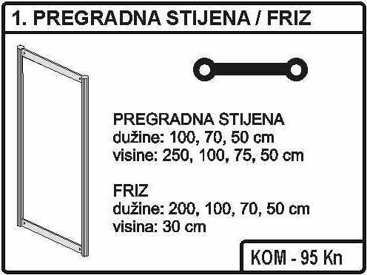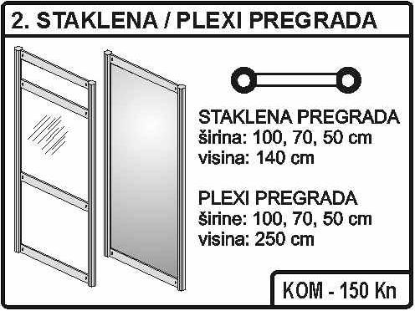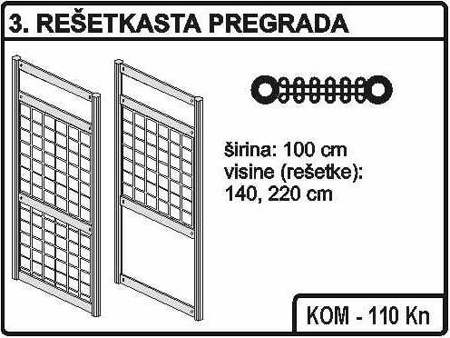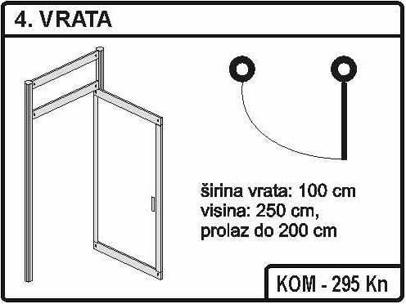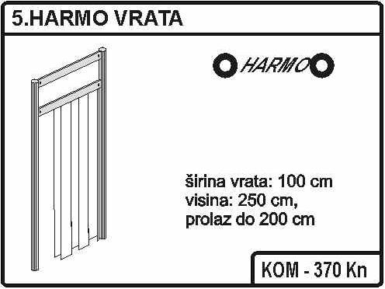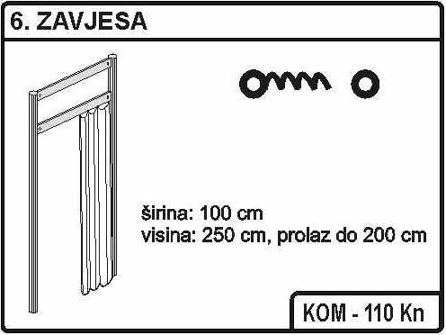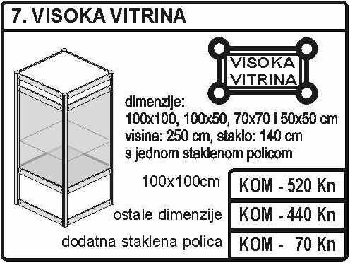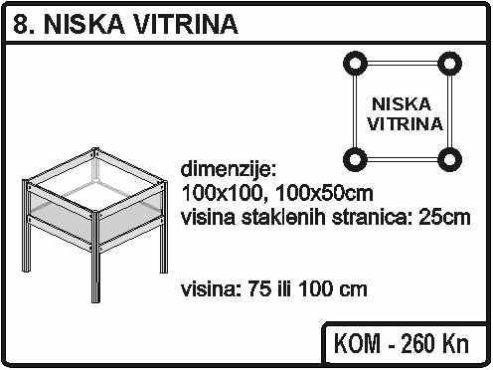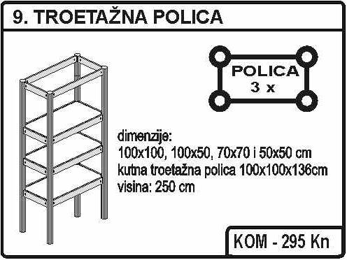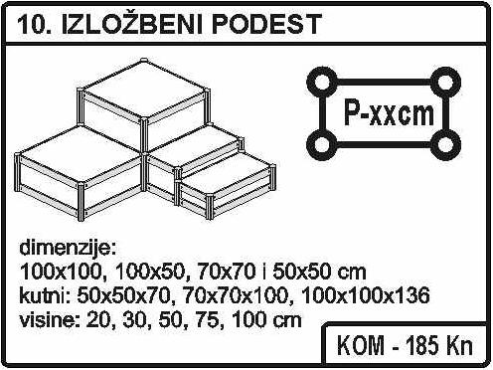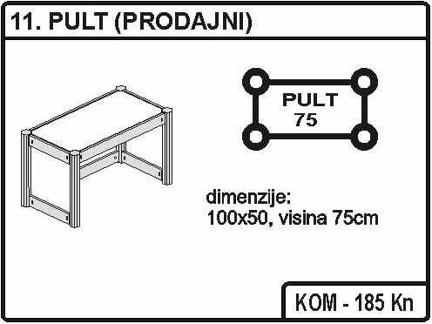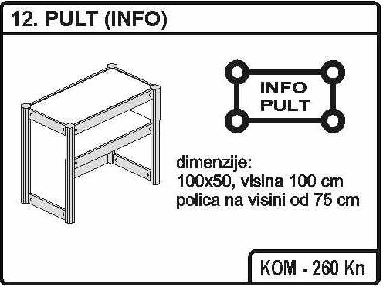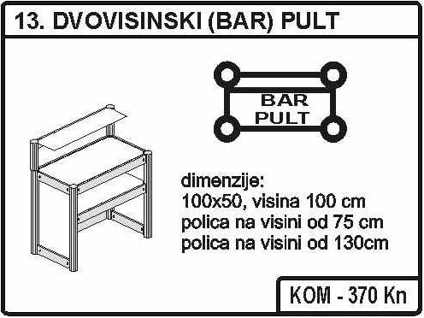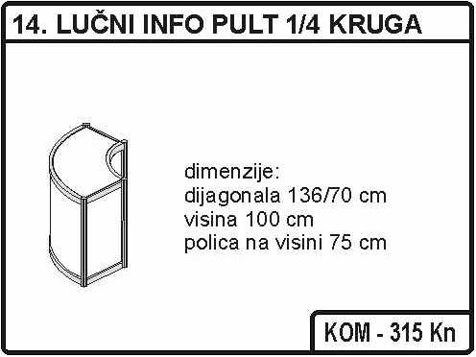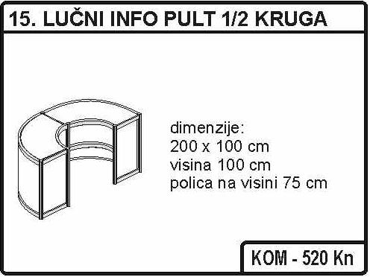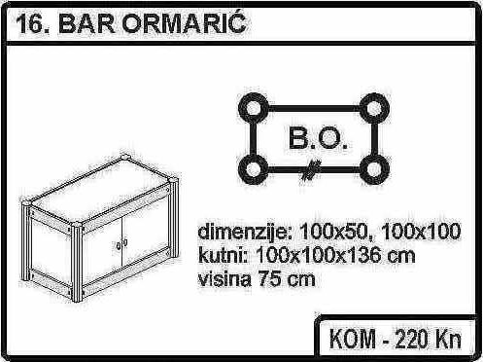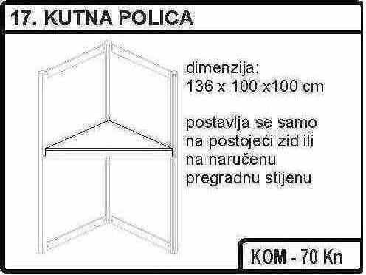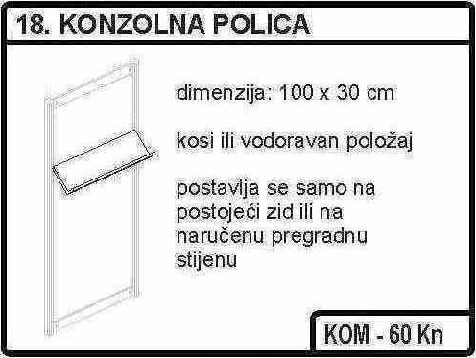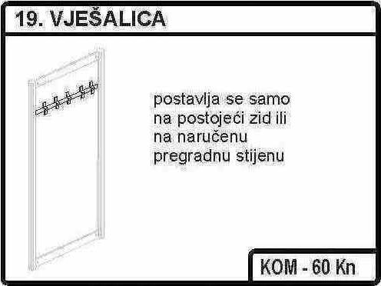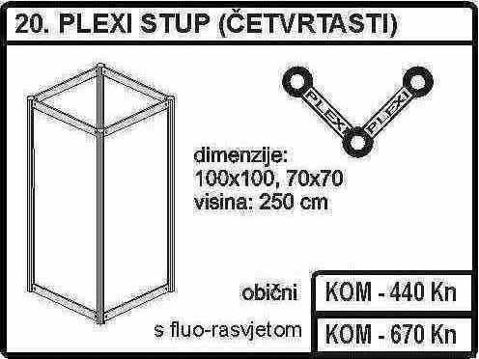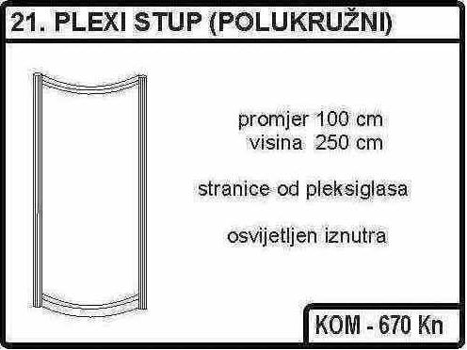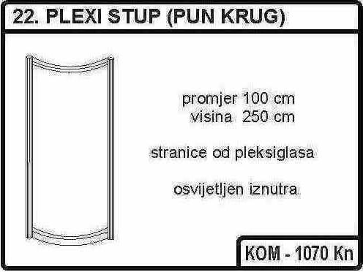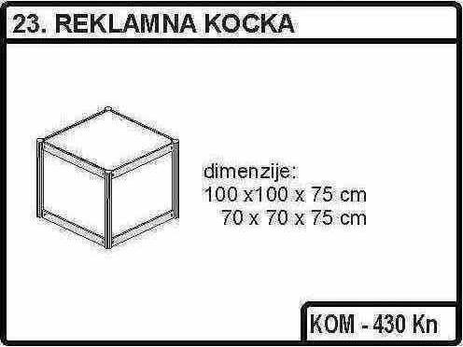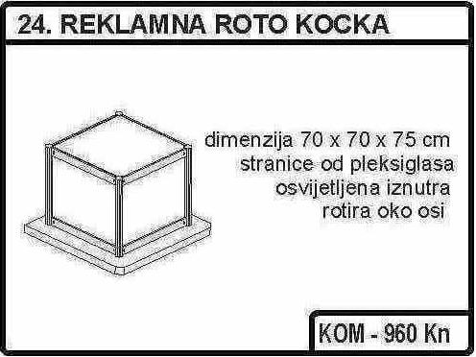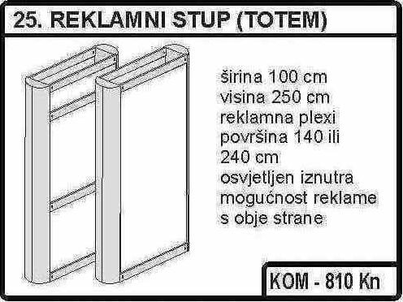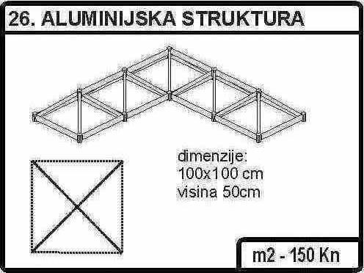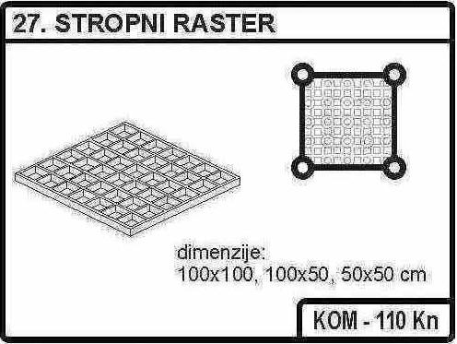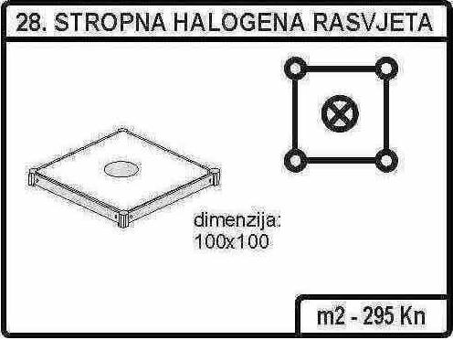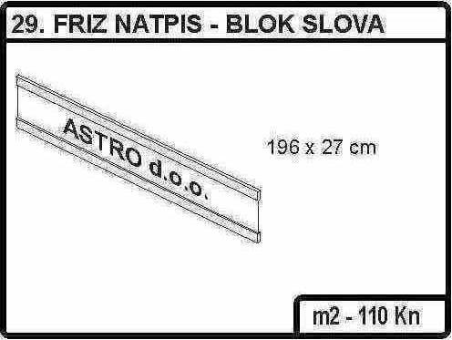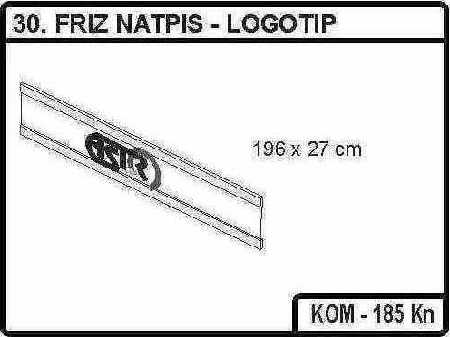CATALGOUE OF ADDITIONAL EQUIPPMENT | WE ARE ORDERING the additional equipment:
PRICES DO NOT INCLUDE VAT! | No. ITEM Price We are ordering  31. TABLE 80x80 cm or round table Fi 80 cm height 75 cm 185 HRK/unit  32. SQUARE TABLE 120x80 cm height 75 cm 300 HRK/ unit  33. BAR TABLE Fi 60 height 130 cm 185 HRK/ unit  34. CHAIR 60 HRK/ unit  35. BAR STOOL 105 HRK/ unit  36. REGRIGERATOR 370 HRK/ unit  37. SINK 295 HRK/ unit  38. SMALL KITCHEN (sink, refrigerator, 2 x camp cooker) 1110 HRK/ unit  39. CAMP COOKER 75 HRK/ unit  40. ELECTRICITY OUTLET 5 Kw 185 HRK/ unit  41. ELECTRICITY OUTLET 10 Kw 295 HRK/ unit  42. ELECTRICITY OUTLET OVER 10 Kw 370 HRK/unit  43. ELECTRIC CLOSET 20 Kw 220 HRK/ unit  44. ELECTRIC CLOSET UNTIL 40 Kw 295 HRK/ unit  45. REFLECTOR 300 W 70 HRK/ unit  46. REFLECTOR UNTIL 500 W 110 HRK/ unit  47. HALOGEN METAL REFLECTOR 150 W 150 HRK/ unit  48. WINDOW BLINDS (for the glass wall No.2) 20 HRK/ unit  49. ALUMINUM LATH VARIOUS LENGHTS 35 HRK/ unit  50. CARPET 30 HRK/m2  51. LAMINATED FLOOR 150 HRK/m2
 | WE ARE ORDERING the following services:
No. | Description | Price in HRK | Quantity | Days | Amount
1. | Hostess | 200,00 HRK/day
2. | Ticket | 8 HRK/day
3. | Cleaning of booth | 5 HRK/m² | m² | For all days of the fair

 | With your signature and seal we certify the order of selected goods and services. We certify that we are acquainted with the rules defined in the FAIR REGULATION of the Crafts and Business fair of the Koprivnica-Križevci County and we are completely accepting them.
 | M.P.
PLACE AND DATE: FIRST AND LAST NAME OF RESPONSIBLE PERSON: SIGNATURE: ___________________________
FAIR REGULATIONS

The Fair regulations contain instructions which regulate registration, exhibition and business activities in the Fair which sets the legal/business relation between the responsible legal person for the financial-commercial activities of the Fair as well as participants-exhibitors.

Registration
Exhibitor registration is submitted in the official registration form in printed letters, and sent signed and certified to the address of the organiser. Orders for fair services are sent in the same manner.
The registration form needs to be sent until 25.10.2019. at the latest. With the sent registration form, the exhibitor complies with the regulations of general conditions for participating in the 22nd Crafts and business fair of Koprivnica-Križevci County 2019 and enters into a direct relation with the responsible legal person for the financial-commercial activities of the Fair.
The registration form is valid only for the registered company and it implies the liability of the exhibitor to display its reported exhibition materials from the opening to the closing of the fair, with the permanent presence of its responsible staff. Abandoning the fair before closing is not permitted. Registered exhibitor without the approval of the organiser cannot sub-lease the allocated exhibiting space. On the contrary, the exhibitor will be removed from the fair and charged in full for all selected orders.

Payment
After sending the registration form, the exhibitor submits prove of payment of ordered services (exhibiting space, marketing services, additional equipment,). Registration without the payment of the amount does not oblige the organiser. When the exhibit registration form is received along with the order for fair services, the responsible legal person for the financial-commercial activities of the Fair issues a quote – advance invoice that needs to be paid in full before setting up the booth. Costs of transaction costs are beard by the exhibitor. After the payment of the amount from the quote, the responsible legal person for the financial-commercial activities confirms to the exhibitor the reservation of the space and enters in a obligation to fulfill all invoiced orders to the exhibitor. Depending on the available space, the responsible legal person for the financial-commercial activities of the Fair can accept the registration form and payment, and after the assigned due dates with the right of increasing prices for increased cost. The exhibitor is obliged to pay the orders places during the Fair immediately.

Reservation and taking over exhibit space
At the Crafts and business fair of the Koprivnica-Križevci County, the exhibitors have the possibility along with the choice of size, to choose for themselves the position of their exhibit space. On the layout plans published on the Internet in the Fair website (www.obrtnicka-komora-koprivnica.hr/sajmovi.aspx) the exhibitor can choose the module/position of its booth by registering the code of the module with the total area of the module. After the exhibitor makes the payment according to the issued quote – advance invoice, the responsible legal person for the financial-commercial activities of the fair marks on the stated layout plans the reservation of the ordered/paid space. If the exhibitor does not take over the ordered space in at least 20 hours before opening of the Fair, it will be assumed that the exhibitor withdraws from exhibition which gives the organiser the right to sell that space to another exhibitor. The exhibitor is obliged to clear out the exhibit space 16 hours after the Fair closes.

Withdrawal
Registered exhibitor can withdraw from exhibiting under specified conditions:
- 45 days before the start of the Fair, in which case the payment will be given back, expect for the fee of the compulsory registration in the fair catalogue.
- 30 days before the start of the Fair, in which case 50% of the payment for Fair orders will be given back, and an invoice for the specified amount is sent out.
Withdrawal in less than 30 days before the start of the Fair is not possible and the organiser will keep the whole amount paid, in other words, the organiser will sent out the invoice to the exhibitor for the incurred costs. Withdrawal is done in writing and due dates start from the date of received of the notification at the headquarters of the legal responsible person of the financial-commercial activities of the Fair. Withdrawal done verbally does not take legal action.

Special regulations
In case when the exhibitor does his booth on its own, the exhibitor is obliged to adhere to the regulations on technical protection, instructions of the organisers and usual standards for international fairs. The exhibitor must secure their own gear and exhibits from being alienated, damaged, destroyed and other risks on its own charge. All other business activities, except exhibiting and selling of exhibits, are regulated with special conditions in a bilateral relation with the responsible legal person for the financial-commercial activities of the Fair and perform them based on a special written permission of the organiser. This regulation refers to the exhibitor when these activities are being carried out also outside of the purchased exhibit space. The exhibitor has the right to get free exhibit ID cards – formal accreditations, and for the space: 6m² = 2 units. 6-16 m² = 3 units, 22 m² and more = 4 units.
Work hours of the fair is from 09:00 a.m. until 07:00 p.m.
Cleaning and maintenance of the booth is the exhibitor's obligation. Cleaning and maintenance of the common fair space is the obligation of the responsible legal person of the financial-commercial activities of the Fair. In the case of changes in the dates of the Fair because of force majeure, the exhibitor does not have the right of damage remuneration from the responsible legal person of the financial-commercial activities of the fair. The responsible legal person of the financial-commercial activities of the fair will give notice to the exhibitor of the new date of the Fair. All eventual disputes are solved by the authorized court in Križevci.

M.P.

PLACE AND DATE: FIRST AND LAST NAME OF RESPONSIBLE PERSON: SIGNATURE: ___________________________

Privacy policy

This Privacy policy was made for the company Crafts and Business Fair j.d.o.o Bjelovarska cesta 75A, 48 000 Koprivnica and it was created in accordance with the General Regulation (EU) number 2016/679 of the European Parliament and of the Council of 27 April 2016, which is applicable from 25 May 2018. In the process of protection and processing of personal data, the Crafts and Business Fair will treat your personal data in accordance with the General Regulation (EU) 2016/679 on the protection of natural persons with regard to the processing of personal data and on the free movement of such data and the Law on the Implementation of the General Data Protection Act (NN 42/2018) or other national law based on the Regulation in question and with the application of appropriate technical and security measures for the protection of personal data against unauthorized access, misuse, detection, loss, or destruction. Based on the General Data Protection Regulation (GDPR), the Crafts and Business Fair is obliged to apply this Regulation and supervise the collection, processing, usage and protection of personal data of all natural persons whose data is collected and used. The Crafts and Business Fair handles your personal information that you have entrusted us through the application form for the 22nd Crafts and Business fair.

Personal data collected through the application form for the payment and organization of the 22nd Crafts and Business Fair are the name/company, address, registry number (VAT no.), business activity (code/description), contact person, bank account number (IBAN), telephone number, e-mail address and the website address according to the rules of the application form for the Fair which was published on the website of the Crafts and Business Fair http://obrtnicka-komora-koprivnica.hr/sajmovi.aspx. In addition to the above mentioned personal data, the photographs taken at the Fair will be used on the mentioned website and on the website of Koprivnica-Križevci County https://kckzz.hr for the purposes of informing the public.

You have the following rights: the right to access and receive information on the process of your personal data, the right that your data is deleted, corrected or amended, the right of restriction, appeal and complaint, the right to identity verification, transfer of personal data and the right to recall the approval as well as the right to request the cessation of personal data processing activities. On your request, the Crafts and Business Fair will at any time, without delay, provide you with your data, delete or amend the incorrect data completely or partially, without charge or explanation. The revocation of the approval does not affect the lawfulness of the processing that was based on the approval before it was withdrawn. You can revoke the approval at any time. If you wish to resubmit your approval, you can do so in the same way as with your revocation. Change of the approval (full or partial revocation or resubmit) can be done via the address or e-mail address. If you revoke your approval, we will no longer use your information for the said purposes. If you wish to exercise any of these rights, please come to us personally. You can also file a complaint with the Croatian Personal Data Protection Agency (www.azop.hr). If you feel that your rights guaranteed by law have been violated, you have the right to personally file a complaint to the personal data processing at the above mentioned address.

The Crafts and Business Fair has taken every technical and organization measures in order to protect your data form loss, alteration or third party access.

If you have any questions, feel free to contact us and we will respond to your requests, inquiries and doubts as soon as possible and help you in exercising your rights.

By signing this application it is considered that you are freely and specifically giving the approval for the collection and processing of your personal data submitted to the Crafts and Business Fair j.d.o.o.

PLACE AND DATE: FIRST AND LAST NAME OF RESPONSIBLE PERSON: SIGNATURE: __________________

22nd Crafts and Business Fair of Koprivnica-Križevci County

PRIJAVA ZA NASTUP
Križevci, 09.-11.11.2007.

REGISTRATION FORM
Križevci, 08.-10.11.2019.

BASIC INFORMATION

ORGANISERS: | CALENDAR:
Fair organizer is: Koprivnica-Križevci County, and co-orginizers are: Town Križevci, HGK-Regional Chamber Koprivnica, Chamber of Trades and Crafts of Koprivnica-Križevci County, Crafts Association Križevci, PORA Regional Development agency of Koprivnica-Križevci County, Tourist Board of Koprivnica-Križevci County, and Tourist Board of Town Križevci. | FINAL REGISTRATION DATE 25.10.2019.  FINAL DATE FOR ADVERTISING MATERIAL DELIVERY 25.10.2019.  FINAL DATE OF PAYMENT 04.11.2019.  SET-UP OF BOOTH 07.11.2019.  FAIR OPENNING 08.11.2019.  FAIR CLOSING 10.11.2019.  BOOTH CLEAN-UP 11.11.2019.
Chamber of Trades and Crafts of Koprivnica-Križevci County is responsible for the financial-commercial business of the Fair. - CONTACT:

ADRESS:
Bjelovarska cesta 75a
48 000 KOPRIVNICA
TEL/FAX: ++ 385 48 623 408
E-mail: ogs.krizevci@gmail.com
WWW: http://obrtnicka-komora-koprivnica.hr/sajmovi.aspx

FAIR DIRECTOR:
Božo Barać
Chamber of Trades and Crafts of
Koprivnica-Križevci County
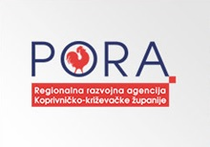
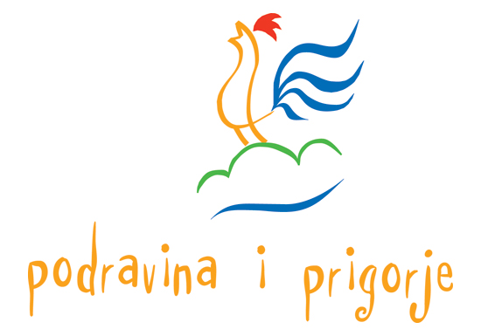

UDRUŽENJE
OBRTNIKA
KRIŽEVCI

